Mars China – Forecast Processing Solution

User Operation Documentation
Table of Contents

1. Modification History 3
2. Document Overview 4
3. Document Assumptions 4
4. Forecast Solution Purpose 4
5. Standards / Definitions 4
5.1. Forecast Processing Solution / Forecast Solution 4
5.2. BW (SAP Business Warehouse) 4
6. Forecast Solution Overview 5
6.1. Environment Diagram 5
6.2. Environment Overview 5
6.3. Core Components 5
7. User Pre-Requisites 6
7.1. User Account Setup 6
7.2. PC Applications (SDS) 6
7.3. Access to Load & Extract Maintenance 6
8. Forecast Load Maintenance 7
8.1. Viewing Forecast Loads 7
8.2. Validation Rules 8
8.3. Create a New Load (Manual) 8
8.4. APOLLO Domestic Forecast Load (Automatic) 10
9. Forecast Extract Maintenance 10
9.1. Viewing Forecast Extracts 10
9.2. Create a New Extract (Manual) 11
10. Frequently Asked Questions (FAQ) 11
10.1. How do I fix an APOLLO forecast in a status of *ERROR 11
10.2. How do I fix a manually loaded forecast in a status of *ERROR 11

Modification History

Date | Version | Description | Reviser
27th March, 2008 | 1.0 | Original | Linden Glen

Document Overview

This document provides user instructions and basic support documentation for users of the Mars China Forecast Processing System.

The following areas are covered:

- Creation/definition of forecasts within the solution
- Definition of various types of forecast inputs
- Creation/definition of forecast outputs (e.g. to FPPS, BW, Apollo, etc…)
- Troubleshooting/Error Message/Alerts/etc.

Document Assumptions

- Reader understands the business processes related to Forecasting across Mars.
- Reader understands the Mars systems in place that are used as part of the planning/forecasting cycle and end outputs/usage.

Forecast Solution Purpose

Within Mars China, various types of forecast are generated in different ways. For example, Domestic forecasts are generated within the system APOLLO and only include quantity measures, whereas Affiliate forecasts are generated manually by users and may already include both quantity and GSV measures. Each forecast type, will have one or more destinations, which could include APOLLO, BW, FPPS, etc.

The Forecast Solution provides a central system for all forecasts to be collated, reviewed, validated and distributed – regardless of source. It also allows for forecasts (where GSV doesn’t exist already) to have GSV applied by using Atlas Pricing conditions.

Standards / Definitions

Forecast Processing Solution / Forecast Solution
- Refers to the application delivered via the web, which users interact with to manage forecast loads and extracts.

BW (SAP Business Warehouse)
- Refers to the global Data Warehouse environment used by Mars.

Forecast Solution Overview

Environment Diagram

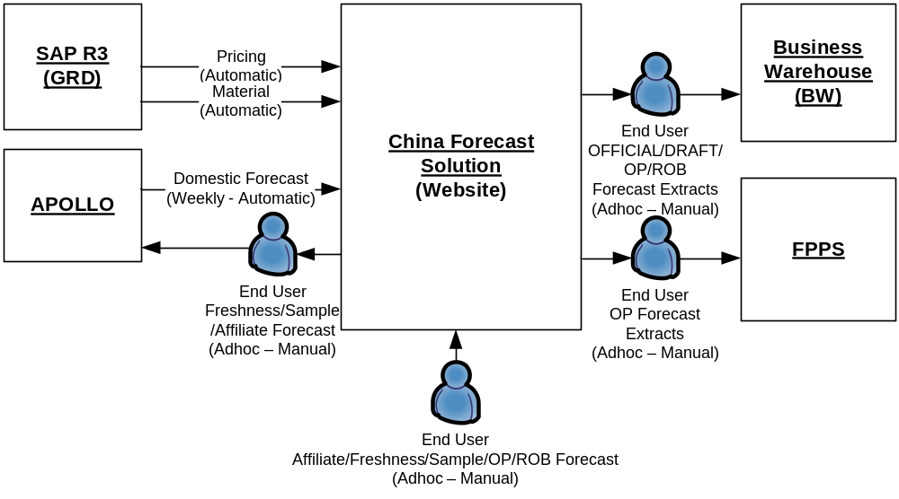

Environment Overview

Tier | Web link
Production | http://clio.ap.mars
Test | http://test.clio.ap.mars

Core Components
The MCH Forecast Solution consists of two core components, which together allow user to manage and review incoming forecasts and extract them to various systems accordingly. The use of these components will be covered in detail further in the document, but at a high level, these components are:
- Forecast Load Maintenance
Provides functionality for the user to review, validate and export historically loaded forecast file, as well as manually create and upload new forecast versions.
- Forecast Extract Maintenance
Provides functionality for the user to generate extracts of loaded forecasts for various downstream systems. This functionality includes validation to ensure forecast extracts are complete and valid.

User Pre-Requisites

User Account Setup
- A user must have a valid MARSDOM account for accessing intranet sites. This can be requested via the PSC (SS 299).
- A user must have FORECAST rights to access the forecasting solution components. This can be requested by raising a Magic ticket to DW_INFO_DELIVERY_AP.
- The user must be connected to the Mars network using a standard Mars SDS PC or laptop.

PC Applications (SDS)
- A user must have Microsoft Office installed on their PC via SDS. This can be requested via the PSC (SS 299).
- A user must have standard Internet Explorer installed on their PC via SDS. This can be requested via the PSC (SS 299).

Access to Load & Extract Maintenance
- When a user browses to the Forecast solution website, they must be able to see the Load Maintenance and Extract Maintenance links. This should appear as follows once the page has completed loading:
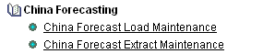
If this is not visible, then the user doesn’t have FORECAST rights. See section 7.1 above.

Forecast Load Maintenance

Viewing Forecast Loads
This is the default view when the user first enters the Forecast Load Maintenance component. It displays all historically loaded forecasts and high level details associated with each. The list is sorted by most recent forecast loads go to the top.

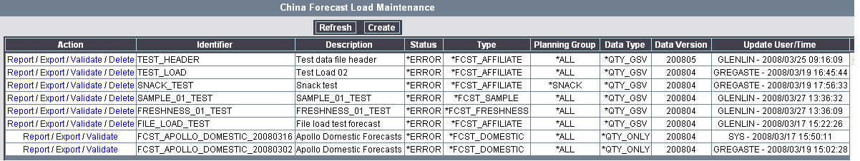

A description of each column in this view is as follows:

Column Name | Details
Action | This column provides several different functions for each forecast.  REPORT : opens an Excel Spreadsheet formatted document containing the data content of the forecast, GSV pricing where available and any error messages associated with each line of the forecast. Types of error messages are “No Pricing available for a given period” and “Not a valid Material Number”.  Export : opens the file exactly as it was received by the system – in the same format. This can be useful not only for troubleshooting, but can also allow a user to download an historical forecast, make adjustments and re-load the file as a new version.  Validate : when a forecast is loaded, it is automatically validated (e.g. for valid pricing conditions, GRD Material codes, etc.). The Validate function allows a user to manually re-execute the validation of the given forecast. This may be used after pricing condition or material errors have been corrected.  Delete : this option is only available for manually loaded forecasts (not those automatically received from Apollo). This function simply removes the forecast record from the system (and this view). Once removed, it cannot be retrieved unless the user is able to re-load the original file.
Identifier | A unique name given to the forecast at time of load. For automated loads from Apollo, this will automatically be generated. Users manually creating loads will be able to specify this (as explained later).
Description | A description given to the forecast at time of load. For automated loads from Apollo, this will automatically be generated. Users manually creating loads will be able to specify this (as explained later).
Status | This displays the result of the Validation. Any forecasts with a status of *ERROR will need to be investigated and corrected before any further processing can occur. Status *VALID means all records within the forecast passed validation rules.
Type | A unique identifier exists for each Forecast Type.
Planning Group | Refers to Business Segment. A forecast can be for *ALL segments or just Pet (*PET) or Snackfood (*SNACK).
Data Type | This displays the source data that was supplied. *QTY_ONLY means that the source file contained only Quantity values – means GSV had to be automatically applied. *QTY_GSV means both quantity and GSV measures were already applied before load.
Data Version | This refers to the Casting Time of the forecast. May be in format YYYYPP or YYYY (in the case of PLAN or REPLAN)
Update User/Time | This field shows the last user and date/time that the forecast was loaded/changed.

Validation Rules
- For forecasts loaded with quantity only, the system will automatically try to lookup pricing for the relevant period and calculate a GSV value. If a pricing condition does not exist for a material in a specified period, that record will be in *ERROR.
- All forecasts records must contain a valid GRD Material code. If the Material Code in the forecast does not exist in the LADS system then it is deemed to be invalid. This may be resolved by either changing the file to use the correct material code, or by requesting the GRD GSM team sends the missing material code(s) to LADS China.

Create a New Load (Manual)

- From the Forecast Load Maintenance screen, click “Create” button at the top of the screen
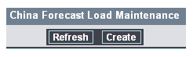
- A data entry screen will display as follows
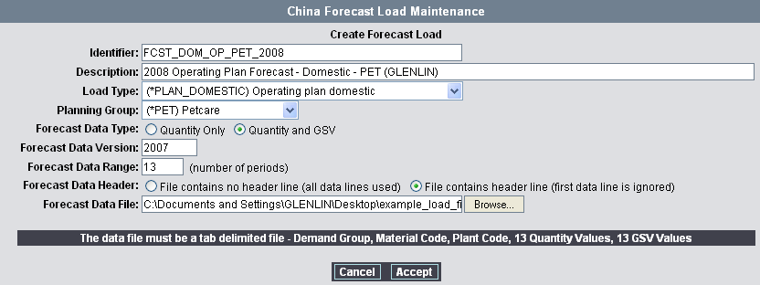
- The fields should be populated as follows
Field Name | Details
Identifier | A unique identifier for the forecast is to be entered here. The identifier shouldn’t be very long, but represent what the forecast is for. For example:  FCST_AFF_PET_20080316  FCST_SAMPLE_ALL_20080316  FCST_OP_2008  Maximum length is 64 characters
Description | A more descriptive detail of the contents of the forecast. May include details like who generated it, and brief notes on changes.  Maximum length is 128 characters
Load Type | The forecast Load Types are self explanatory. One of these must be selected as part of the load.  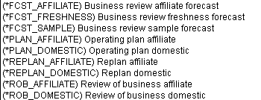
Planning Group | The Planing Group refers to the Business Segment the Forecast is for. Currently, ALL, PET or SNACK are available.  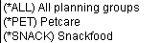
Forecast Data Type | A forecast source file must contain quantity measures. It may or may not also contain pre-calculated GSV measures. If the “Quantity Only” option is selected, then the load will automatically attempt to apply GSV based on existing pricing conditions. If the “Quantity and GSV” option is selected, then no GSV processing will be undertaken and GSV values in the source file will be used.
Forecast Data Version | The casting version of the forecast. May be in the format YYYYPP or YYYY (in the case of yearly forecasts like PLAN or REPLAN).
Forecast Data Range | This indicates the number of periods the source file spans.  Maximum value is 999.
Forecast Data Header | This option allows the user to load a file that has headers in it (making it easier to view on screen). Selecting “File contains header line” will force the load to ignore the first line in the file and only load lines from 2 onwards.
Forecast Data File | Use the “Browse” button to select the source forecast file to load.  Here is an example of how to generate a load file in Excel:  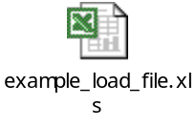  Once the data is entered as required, simply “Save As” Text (Tab Delimited) and the resulting file will be ready for loading.  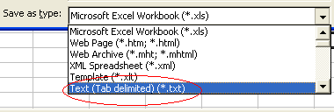

- Once the above information is entered, press the “Accept” button to load the file. Once this is clicked, a yellow “Processing…” box will appear.
- Once the load is complete, you will automatically be taken back to the default view page in Forecast Load Maintenance. If you entered any data incorrectly, you will receive a pop-up window informing you of the error(s).
- You should now see your loaded forecast in the view

APOLLO Domestic Forecast Load (Automatic)
Every week (usually Sunday evenings), Apollo will automatically generate a Domestic forecast for Mars China and send it to the Forecast Solution. Once the forecast solution has received this file, it will automatically become available in the Forecast Load Maintenance view. From there, you can Report/Export/Validate as necessary.

Forecast Extract Maintenance

Viewing Forecast Extracts
This is the default view when the user first enters the Forecast Extract Maintenance component. It displays all historically extracted forecasts and high level details associated with each. The list is sorted by most recent forecast loads go to the top.
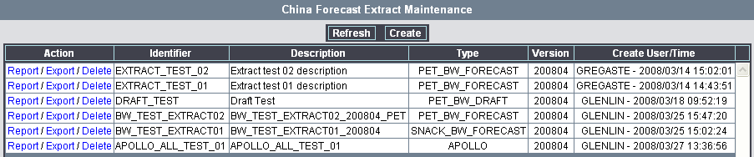

A description of each column in this view is as follows:

Column Name | Details
Action | This column provides several different functions for each forecast.  REPORT : opens an Excel Spreadsheet formatted document containing the data content of the forecast. The file is laid out to clearly show the forecast information, including quantity and GSV measures. This function is used only for the end users information.  Export : processes and builds a file for extract to a downstream system. Where a manual load into a downstream system (like FPPS) is required, the file will be opened on the users PC. Where the file is automatically sent to a downstream system (like Apollo), clicking this function will cause it to send immediately.  Delete : This function simply removes the forecast extract record from the system (and this view). Once removed, it cannot be retrieved.
Identifier | A unique name given to the forecast extract at time of extract.
Description | A description given to the forecast extract at time of extract creation.
Type | A unique identifier exists for each Forecast Extract Type.
Version | This refers to the Casting Time of the forecast. May be in format YYYYPP or YYYY (in the case of PLAN or REPLAN)
Create User/Time | This field shows the user and date/time that the forecast extract was created.

Create a New Extract (Manual)

- From the Forecast Extract Maintenance screen, click “Create” button at the top of the screen
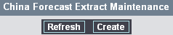
- A data entry screen will display as follows
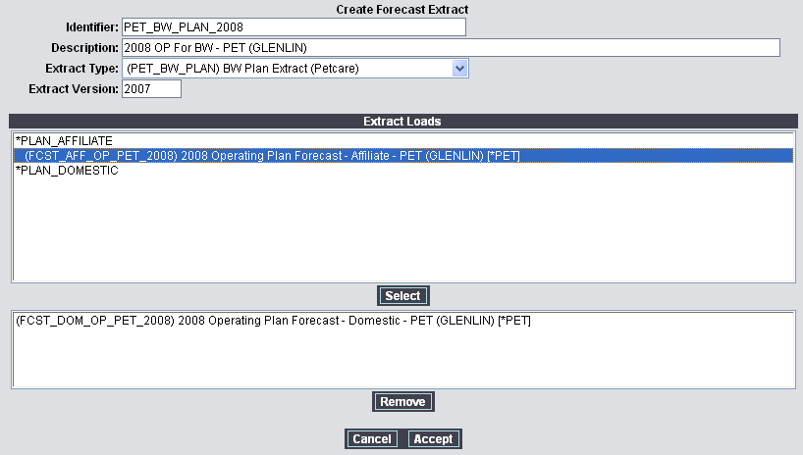

- The fields should be populated as follows
Field Name | Details
Identifier | A unique identifier for the forecast extract is to be entered here. The identifier shouldn’t be very long, but represent what the extract is for. For example:  FCST_PET_BW_20080316  FCST_OP_2008_BW  FCST_OP_2008_FPPS  Maximum length is 64 characters
Description | A more descriptive detail of the contents of the extract. May include details like who generated it, and brief notes on changes/extract details.  Maximum length is 128 characters
Extract Type | The Extract Types are self explanatory. One of these must be selected as part of the extract.  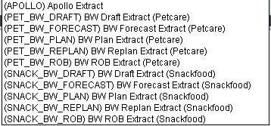
Extract Version | The extract version is the Casting version of data that you wish to select from. The forecast data must be loaded and *VALID (see Forecast Load Maintenance) and be for the Casting version entered for it to be extracted.
Extract Loads (Box 1) | Once an Extract Type and Extract Version has been selected/entered, this box will automatically populate with all *VALID Forecasts that have been loaded into the system. The user must select the relevant forecasts for each sub-heading and for each one click the “Select” button.  This will move the forecast from Box 1 to Box 2.
Extract Loads (Box 2) | This box will display any forecasts that have been selected from Box 1. Each Extract Type will have validation behind it to ensure the correct number and forecasts have been selected for extract.  For example, the PET_BW_PLAN Extract Type requires both an Affiliate and Domestic PET PLAN forecast to be selected.

- Once the above information is entered, press the “Accept” button to create the extract. Once this is clicked, a yellow “Processing…” box will appear.

System Information

Historical Data Retention (Purging)
This is the default view when the user first enters the Forecast Load Maintenance component. It displays all historically

Frequently Asked Questions (FAQ)

How do I fix an APOLLO forecast in a status of *ERROR
This is the default view when the user first enters the Forecast Load Maintenance component. It displays all historically

How do I fix a manually loaded forecast in a status of *ERROR
This is the default view when the user first enters the Forecast Load Maintenance component. It displays all historically

